**BASAVARAJESWARI GROUP OF INSTITUTIONS**

**BALLARI INSTITUTE OF TECHNOLOGY & MANAGEMENT**

****NACC Accredited Institution*

**(Recognized by Govt. of Karnataka, approved by AICTE, New Delhi & Affiliated to**

**Visvesvaraya Technological University, Belagavi)**

**"JnanaGangotri" Campus, No.873/2, Ballari-Hospet Road, Allipur,**

**Ballar1-583 104 (Karnataka) (India)**

**Ph: 08392 – 237100 / 237190, Fax: 08392 – 237197**

**DEPARTMENT OF COMPUTER SCIENCE & ENGINEERING**

**A Mini-Project Report**

**On**

**“**ATOMIC STRUCTURE**”**

**A report submitted in partial fulfilment of the requirements for the**

**MINI PROJECT OF COMPUTER GRAPHICS LABORATORY (18CSL67)**

**Submitted By**

**UTKARSH KUMAR USN: 3BR20CS0173**

**UMME KULSUM USN: 3BR20CS172**

**Under the Guidance of**

**Mr. Usman K. Asst. Prof.**

**Mrs. Lakshmi Sharma Asst. Prof.**

**Dept. of CSE**



[**Visvesvaraya Technological University**](http://www.vtu.ac.in/)

**Belagavi, Karnataka 2022-2023**

**BASAVARAJESWARI GROUP OF INSTITUTIONS**

**BALLARI INSTITUTE OF TECHNOLOGY & MANAGEMENT**

NACC Accredited Institution*

**(Recognized by Govt. of Karnataka, approved by AICTE, New Delhi & Affiliated to**

**Visvesvaraya Technological University, Belagavi)**

**"JnanaGangotri" Campus, No.873/2, Ballari-Hospet Road, Allipur,**

**Ballar1-583 104 (Karnataka) (India)**

**Ph: 08392 – 237100 / 237190, Fax: 08392 – 237197**



**DEPARTMENT OF COMPUTER SCIENCE & ENGINEERING**

**CERTIFICATE**

This is to certify that the MINI PROJECT of COMPUTER GRAPHICS LABORATORY entitle **“**ATOMIC STRUCTURE**”** has been successfully presented by **UTKARSH KUMAR** bearing USN **3BR20CS173 and UMMA KULSUM** bearing USN **3BR20CS172** students of VI semester B.E for the partial fulfilment of the requirements for the award of **Bachelor Degree in Computer Science and Engineering** of the VISVESVARAYA TECHNOLOGICAL UNIVERSITY, BELGAVI during the academic year 2022-2023.

Signature of guideSignature of HOD

**Mr. Usman K. Dr. R.N. Kulkarni**

**Mrs. Lakshmi Sharma**

**External viva**

**Name of the examiners Signature with date**

**1.__________________**

**2.__________________**

**ACKNOWLEDGEMENT**

The satisfactions that accompany the successful completion of our mini project on **“**ATOMIC STRUCTURE**”** would be incomplete without the mention of people who made it possible, whose noble gesture, affection, guidance, encouragement and support crowned my efforts with success. It is our privilege to express our gratitude and respect to all those who inspired us in the completion of our mini-project.

We are extremely grateful to our Guides **Mr. Usman K. and Mrs. Lakshmi Sharma** for their noble gesture, support co-ordination and valuable suggestions given in completing the mini-project. We also thank **Dr. R. N. Kulkarni,** H.O.D. Department of CSE, for his co-ordination and valuable suggestions given in completing the mini-project. We also thank Principal, Management and non-teaching staff for their co-ordination and valuable suggestions given to us in completing the mini-project.

|  |  |  |
| --- | --- | --- |
|  | Name | USN |
|  | Utkarsh Kumar | 3BR20CS173 |
|  | Umma Kulsum | 3BR20CS172 |

|  |  |  |  |  |  |  |  |  |  |  |  |  |  |  |  |  |  |  |  |  |  |  |  |  |  |  |  |  |  |  |  |  |  |  |  |  |  |  |  |  |  |
| --- | --- | --- | --- | --- | --- | --- | --- | --- | --- | --- | --- | --- | --- | --- | --- | --- | --- | --- | --- | --- | --- | --- | --- | --- | --- | --- | --- | --- | --- | --- | --- | --- | --- | --- | --- | --- | --- | --- | --- | --- | --- |
| |  |  |  | | --- | --- | --- | | **TABLE OF CONTENTS** | | | | **Chapter No** | **Chapter Name** | **Page No** | |  | Acknowledgement | I | |  | Table of Contents | II | | 1 | Introduction |  | |  | 1.1 About the Project | 3 | |  | 1.2 Problem Statement | 3 | |  | 1.3Objectives of the Project | 3 | | 2 | System Requirements and Specifications  2.1 Software Requirements  2.2Hardware Requirements | 4  4 | |  |  |  | | 3 | Implementation  3.1 Function/Method description  3.2 Results (Screen shots of the output) | 5  7 | | 4 | Conclusion | 12 | |  |  |  | | | |
|  |  |  |
|  |  |  |
|  |  |  |
|  |  |  |
|  |  |  |
|  |  |  |
|  |  |  |
|  |  |  |
|  |  |  |
|  |  |  |
|  |  |  |
|  |  |  |

**CHAPTER 1: INTRODUCTION**

* 1. **ABOUT THE PROJECT**:

The Atom Simulation project is an educational application developed using the OpenGL graphics library. It aims to provide users with a visually immersive experience to explore the arrangement of electrons in different elements and understand atomic structures. The application features a dynamic simulation where a nucleus is depicted at the center, surrounded by orbiting electrons. Users can interact with the simulation by selecting elements from a menu, controlling the rotation of electrons, and resizing the window for a better view. The graphics rendered using OpenGL are visually appealing, and smooth animations enhance the user experience. With its intuitive user interface and customizable features, the Atom Simulation project offers an engaging and interactive learning platform for users to gain a deeper understanding of atomic structures and electron orbits.

* 1. **PROBLEM STATEMENT:**

To Develop an Atom Simulation using OpenGL to visualize electron orbits in different elements. Users can interact with the simulation through menus, control electron rotation, and resize the window.

* 1. **OBJECTIVES OF THE PROJECT:**

The objectives of the Atom Simulation project are as follows:

* To develop a simulation using OpenGL to visually represent electron arrangements in different elements and atoms, ensuring accurate and realistic depictions.
* To enable users to interact with the simulation by selecting elements, controlling electron rotations, and adjusting the window size, providing a dynamic and engaging experience.
* To create an immersive and informative learning platform using OpenGL, where users can explore atomic structures and electron orbits to deepen their understanding.
* To design an intuitive and user-friendly interface with easy-to-use controls, clear labels, and informative text rendering, ensuring a seamless user experience.
* To utilize the capabilities of OpenGL to deliver visually appealing graphics with smooth animations, enhancing the overall visual quality and immersion of the simulation.

**CHAPTER2:**

**SYSTEM REQUIREMENTS AND SPECIFICATIONS:**

**2.1 HARDWARE REQUIREMENTS:**

* Processor **:**13
* Hard Disk **:**500 GB
* RAM **:**8 GB
* Input **:**Keyboard, Mouse
* Graphics Card (GPU) **:**1GB
* Display **:**1920x1080 (Full HD).

**2.2 SOFTWARE REQUIREMENTS:**

* Operating System **:** Windows 8.1
* Software Tools **:** DEV C++
* Coding Language **:** C, C++
* Toolbox **:** OpenGL Libraries and Headers:

1. Extension Wrangler Library (GLEW)
2. Utility Toolkit (GLUT)

* Compiler: **:** Dev-C++ --- GCC compiler for C and C++ code compilation

**CHAPTER 3: IMPLEMENTATION**

* 1. **FUNCTION/METHOD DESCRIPTION:**

**1. void init():**

- Initializes the OpenGL orthographic projection for the simulation window.

**2. void circle(float rad):**

- Draws a circle with the specified radius.

- Used to draw the nucleus and electron orbits.

**3. void drawString(float x, float y, float z, char *string):**

- Draws a string of characters at the specified position (x, y, z).

- Used to render text on the simulation window.

**4. void drawhead(float x, float y, float z, char *string):**

- Draws a larger-sized string of characters at the specified position (x, y, z).

- Used to render larger text for headings.

**5. void drawsubhead(float x, float y, float z, char *string):**

- Draws a medium-sized string of characters at the specified position (x, y, z).

- Used to render medium-sized text for subheadings.

**6. void nuc(float rad):**

- Draws a filled polygon to represent the nucleus of an atom.

- Used to draw the nucleus of an element.

**7. void eleright(float rad), eleleft(float rad), eletop(float rad), eledown(float rad), eletr(float rad), eletl(float rad), eledl(float rad), eledr(float rad):**

- Draws filled polygons to represent electrons in their respective orbits.

- Used to draw the electrons orbiting the nucleus.

**8. void display():**

- Renders the graphics and updates the simulation window.

- Handles different cases based on the value to display various elements and text.

**9. void rotate():**

- Updates the angle for electron rotation.

- Used to rotate the electrons around the nucleus.

**10. void mouseControl(int button, int state, int x, int y):**

- Handles mouse button events.

- Used to start or stop the rotation of electrons based on mouse button clicks.

**11. void keyboard(unsigned char key, int x, int y):**

- Handles keyboard events.

- Used to control various functionalities such as starting/stopping rotation, returning to the home screen, and exiting the application.

**12. void fkey(int key, int x, int y):**

- Handles special function key events.

- Used to handle resizing the window.

**13. void menu(int option):**

- Handles menu selection events.

- Used to update the value based on the selected option and perform corresponding actions.

**14. void createMenu():**

- Creates the menu structure and attaches it to the right mouse button.

- Used to create and attach the menu for selecting different elements and accessing additional options.

**15. int main(int argc, char **argv):**

- The main function of the program.

- Initializes the OpenGL window, sets up callbacks, creates the menu, and starts the main event loop.

* 1. **RESULTS (SCREEN SHOTS OF THE OUTPUT):**

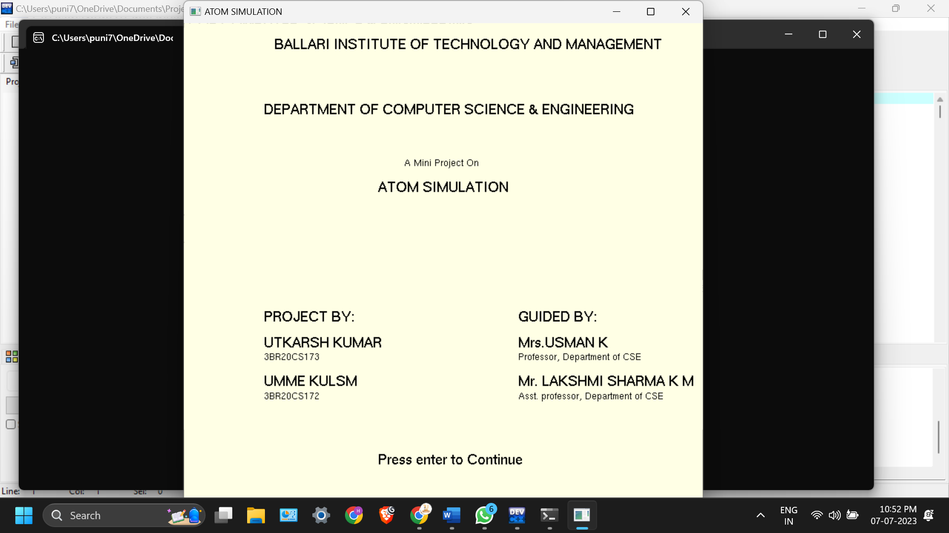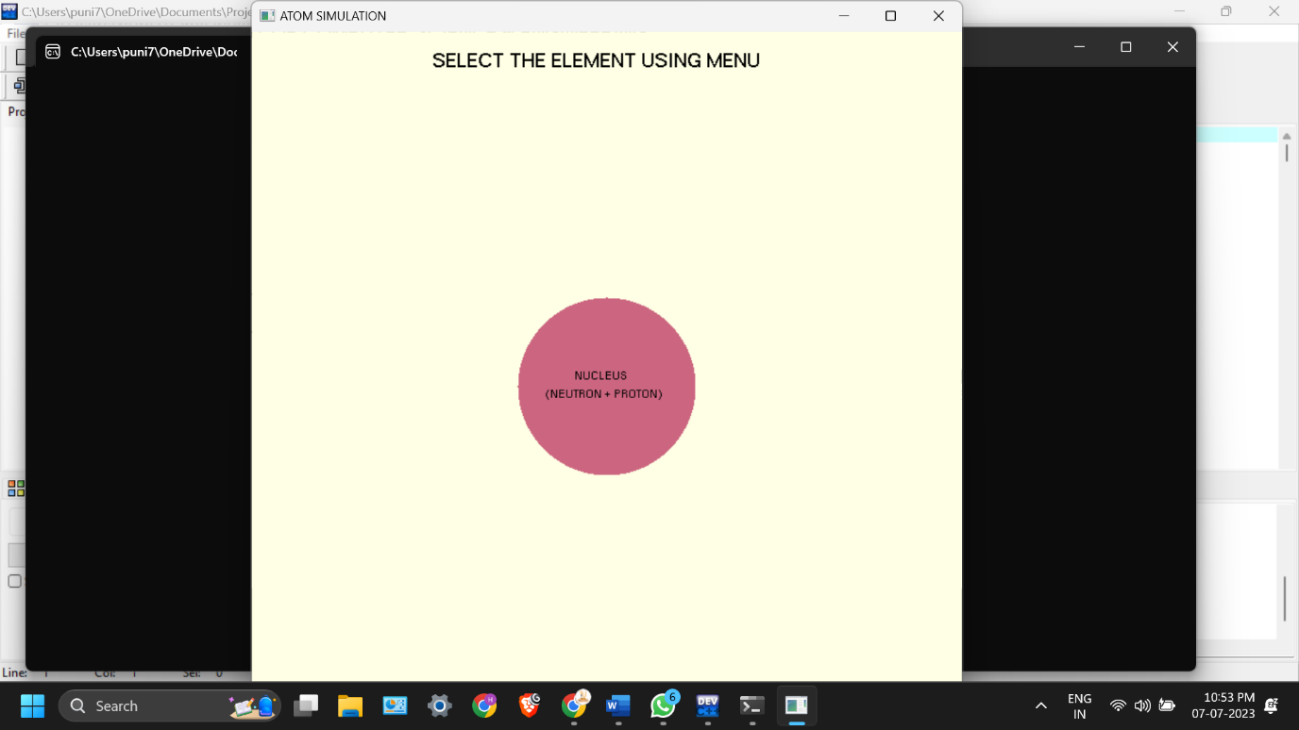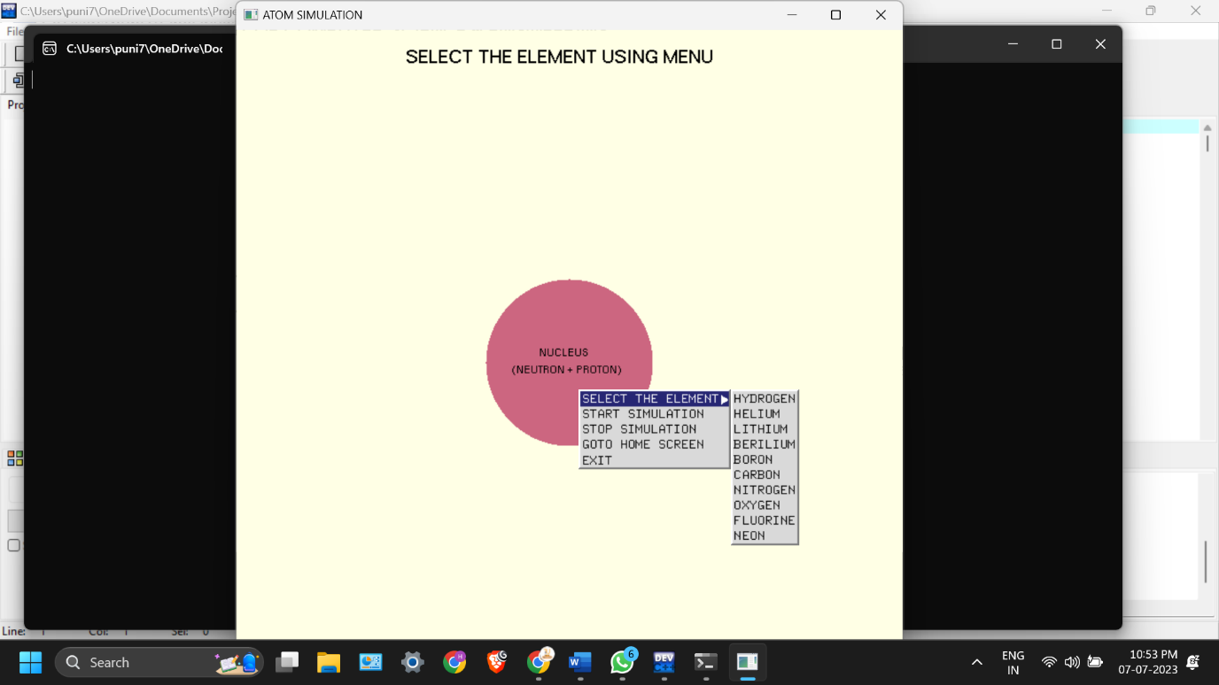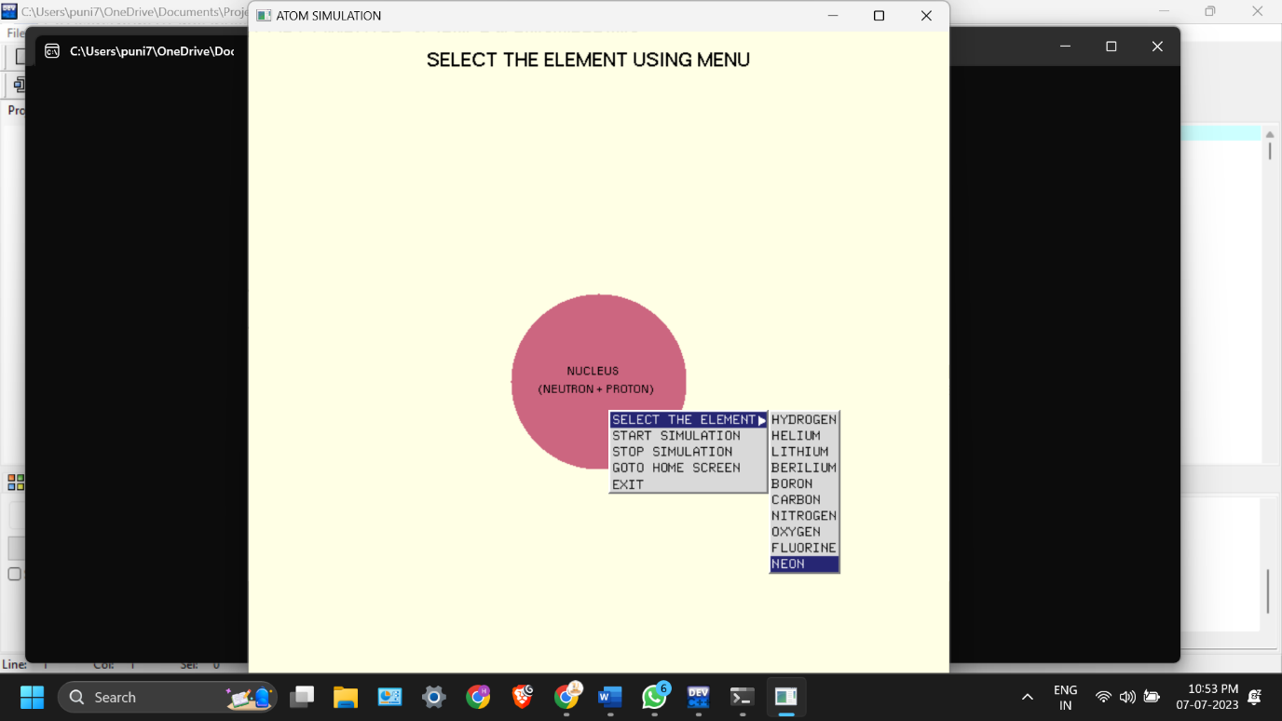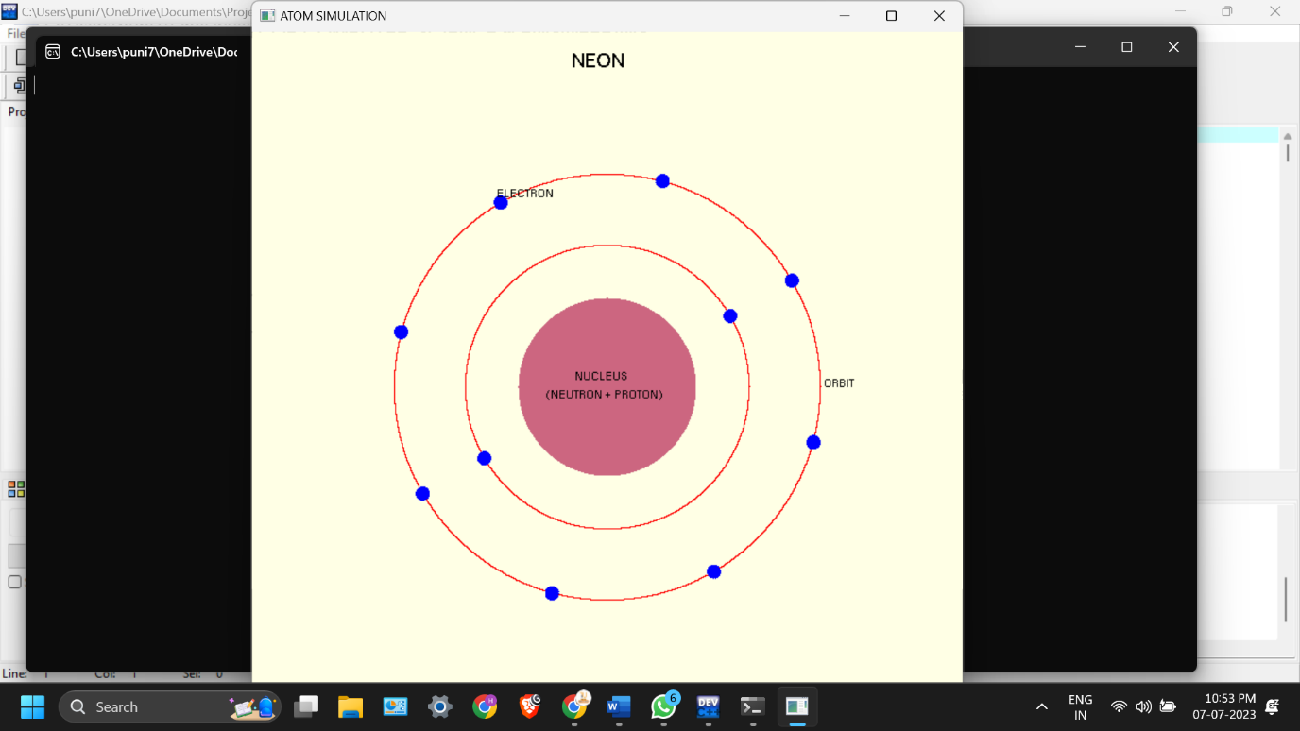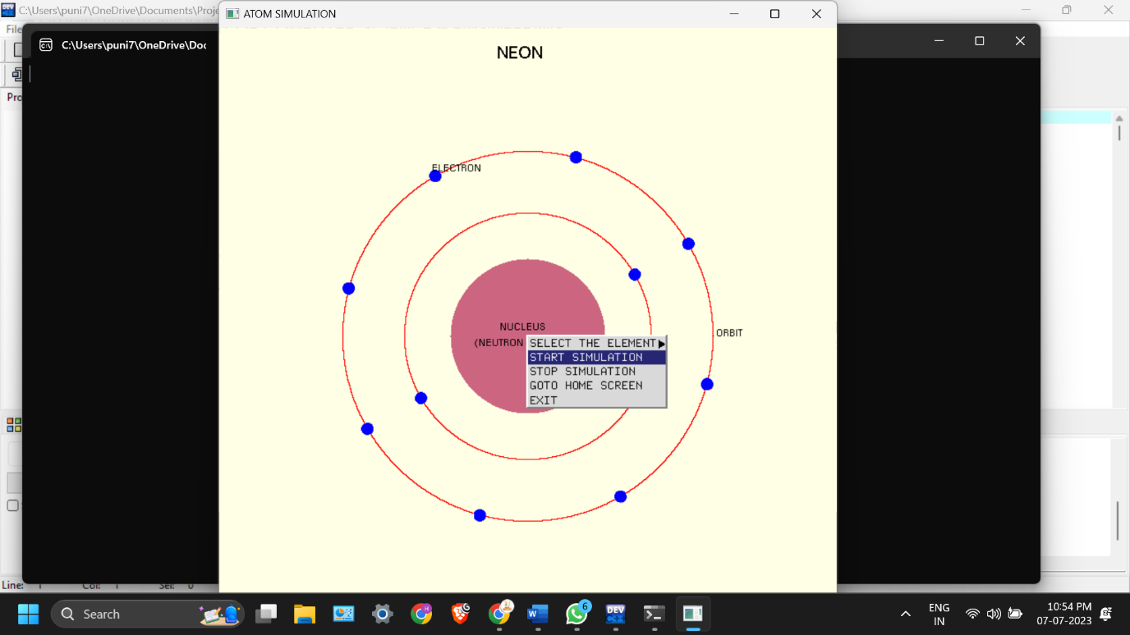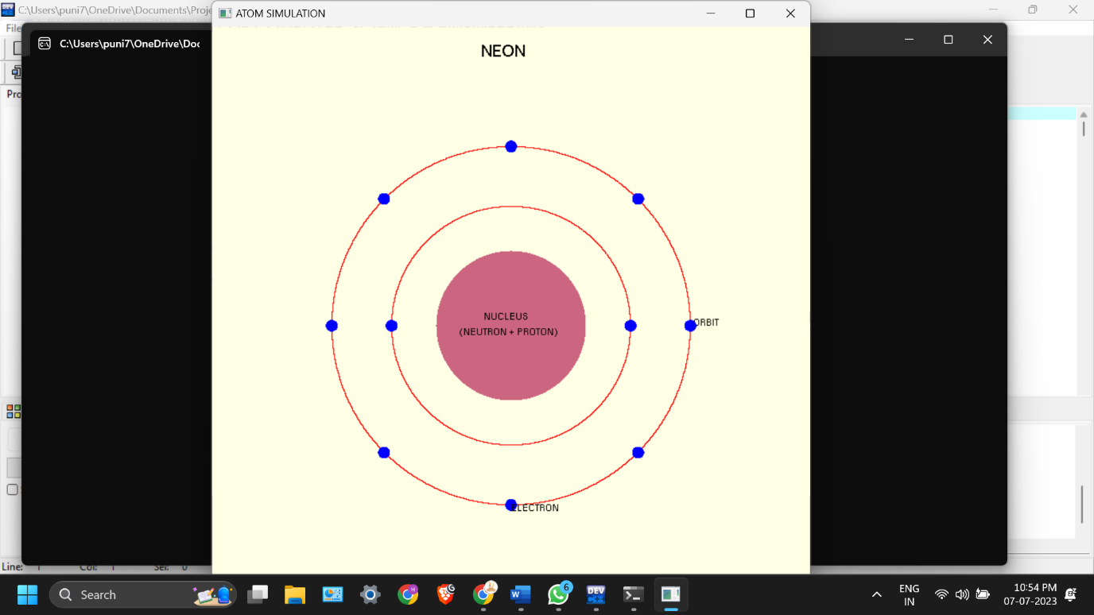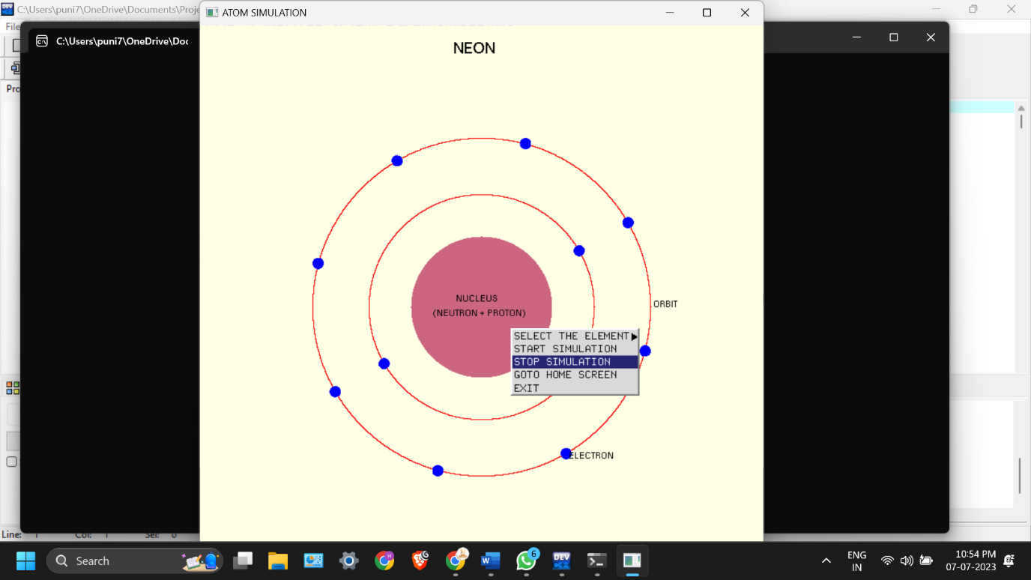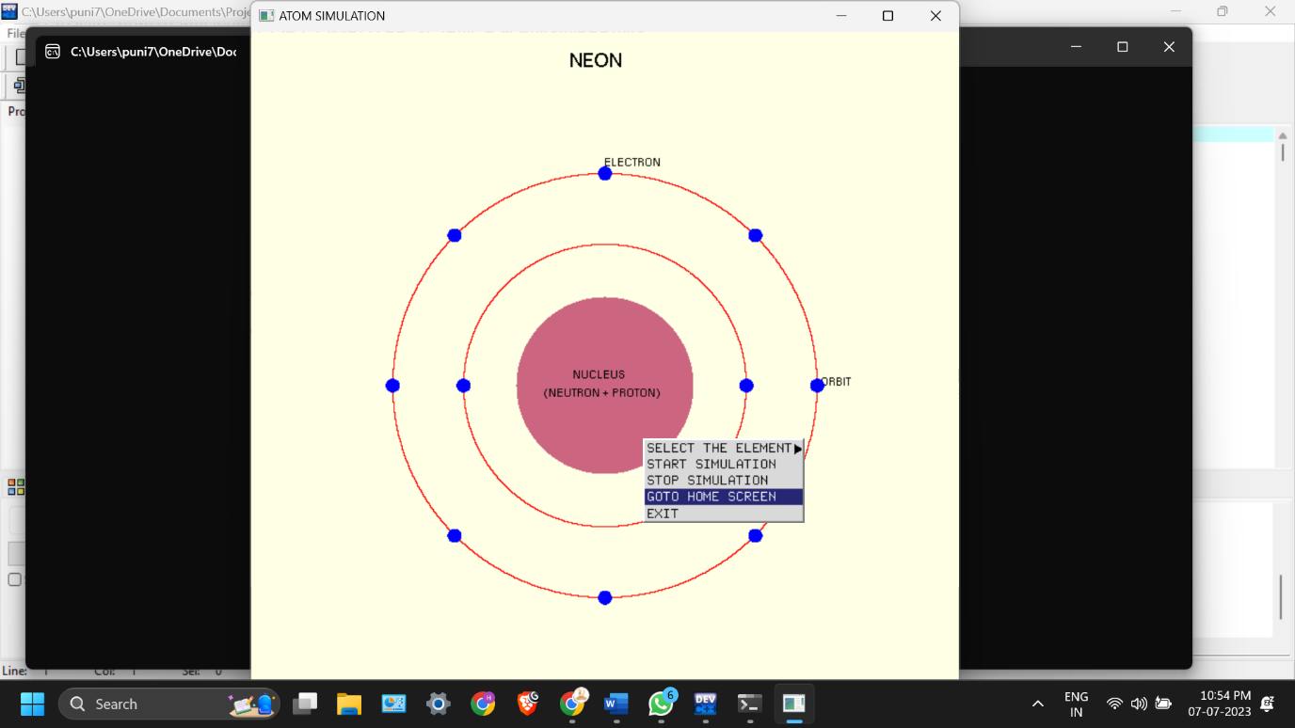

**CHAPTER 4:**

**CONCLUSION:**

In conclusion, the Atom Simulation project developed using the OpenGL graphics library provides an immersive and interactive learning experience for understanding atomic structures and electron orbits. The project successfully visualizes the arrangement of electrons in different elements, allowing users to explore and interact with the simulation. With its user-friendly interface, customizable features, and informative text rendering, the project offers a comprehensive platform for educational purposes. By leveraging the capabilities of OpenGL, the simulation achieves visually appealing graphics and smooth animations, enhancing the overall user experience. The project's objectives have been met, providing users with an engaging and realistic simulation to deepen their understanding of atomic structures.